Ex 5. ESP32 sending the data using HTTP

Write programs for ESP32 to send the sensors data (temperature, humidity, motion sensor as collecting in exercise 4) to the server (e.g. postman server)
Using wokwi https://wokwi.com/
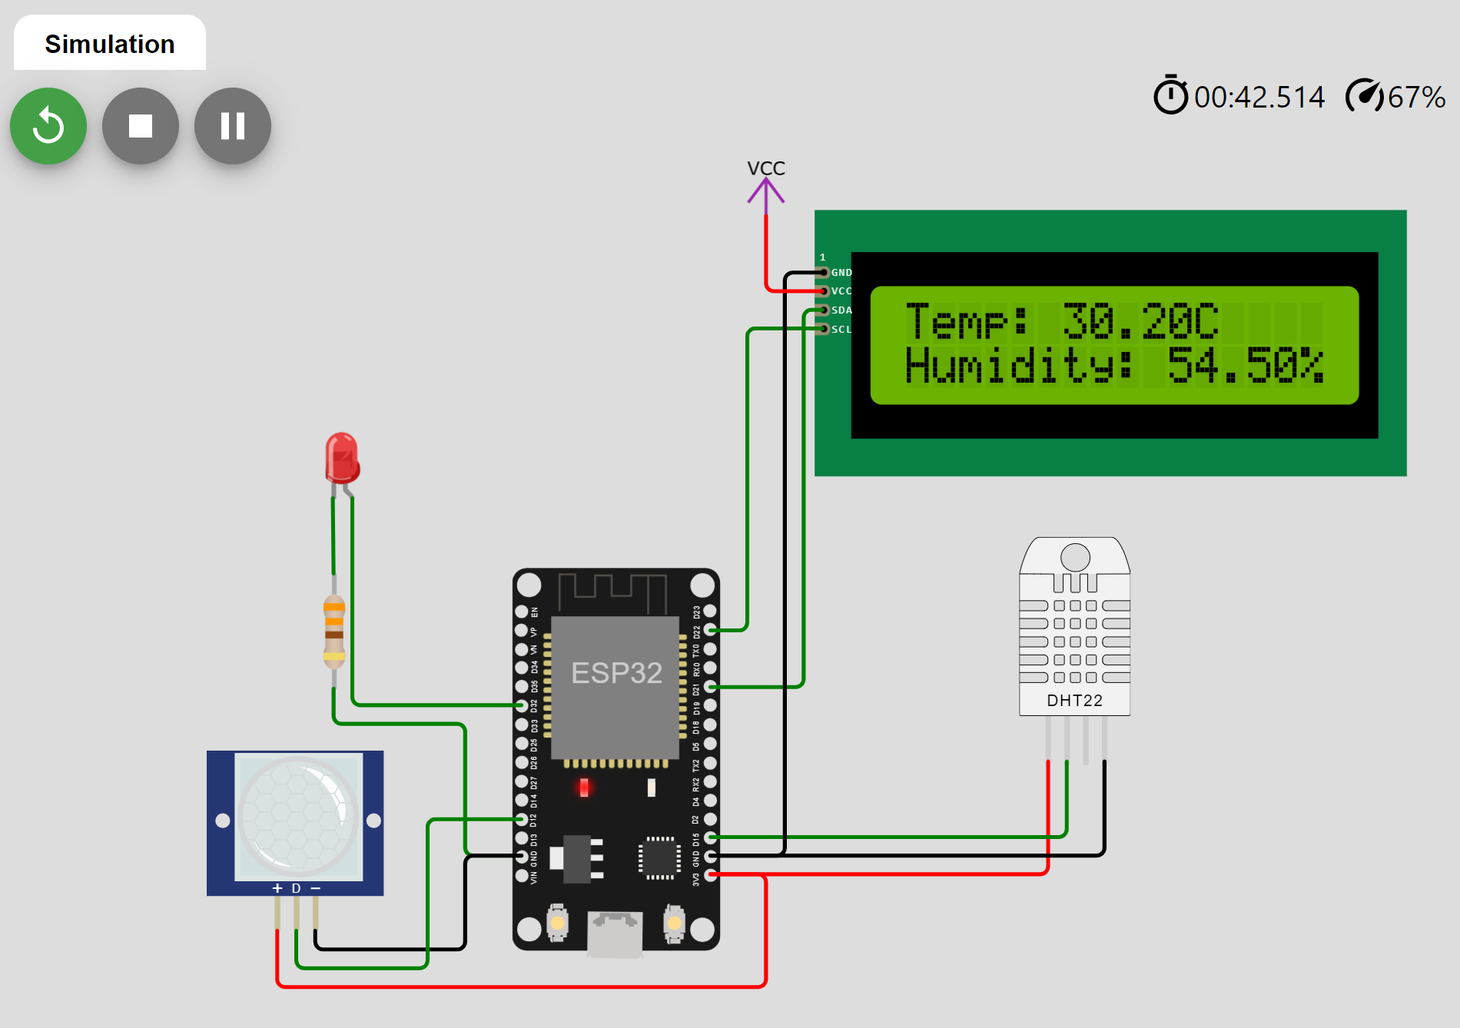
Requirement of programs:
a) Send the data using HTTP get request, the content-type is url-encoded
b) Send the data using HTTP post request, the content-type is url-encoded
c) Send the data using HTTP post request, the content-type is json (in request body)
Using the server api:
https://postman-echo.com/get
https://postman-echo.com/post

Submission:
Write a report with:
- The code of programs with suitable comments
- Screen photos when running programs
- Link of simulations with wokwi

Example for using ArduinoJson library
float x = 30.5;
float y = 78;

DynamicJsonDocument doc(1024);
String jsonstr;
JsonObject root = doc.to<JsonObject>();
root["temperature"] = x;
root["humidity"] = y;
serializeJson(doc, jsonstr);
String httpRequestData = jsonstr;

https://arduinojson.org/v6/example/string/

